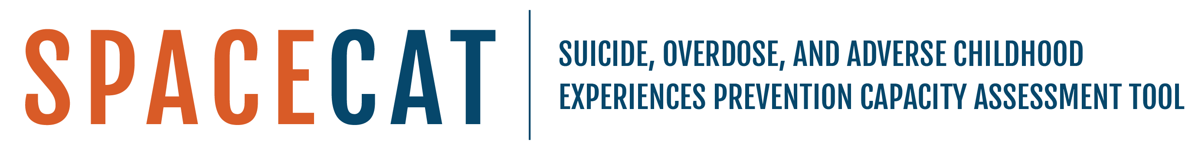

SPACECAT Note-Taking Sheet

Purpose: This supplemental notetaking sheet is an optional handout that you and your team can utilize to capture any additional comments, questions, or takeaways that arise during the completion of the tool.

Instructions: Please note the date that you completed the tool and the names of the agency staff members who contributed to the completion of the tool. As you and your team complete the tool, please use the right-side column to elaborate on the conversations that you and your team had as you were completing each section. You may use the italicized questions in the left-side column to help guide notetaking and discussion among your team. Once you and your team have finished the tool, feel free to use the Decisions & Action Items section to develop next steps for integrating any main takeaways into your work.

Date of Tool Completion
Names of agency staff involved in completing the tool

Tool Notes:

Section I: Background
What steps did you take to complete the background section (e.g., who did you tap or collaborate with)?

Are there any external partners that could help you address the intersection of these three topic areas?

Are there other risk and/or protective factors that your work addresses?

Were there any particularly challenging questions?

Were there any questions that you are still unsure about?
What are some takeaways from this section?
Section II: Infrastructure Capacity
What steps did you take to complete the infrastructure section (e.g., who did you tap or collaborate with)?

Do any of your partnership activities overlap in these three topic areas?

Were there any partnerships, funding, and/or data sources not mentioned in the tool that you would like to make a note of?

How can you utilize data to address the intersection of ACEs, suicide, and overdose prevention?

What are some actionable steps you can take to increase collaboration at the leadership level? At a programmatic level?

Are there any other challenges that your team faces when addressing ACEs, suicide, and overdose prevention?

Were there any particularly challenging questions?

Were there any questions that you are still unsure about?

What are some takeaways from this section?

Section III: Topical Capacity
What steps did you take to complete the topical capacity section (e.g., who did you tap or collaborate with)?

What actions could you take to address the capacity to implement ACEs, suicide, and/or overdose prevention at each level of intervention?

Were there any particularly challenging questions?

Were there any questions that you are still unsure about?

What are some takeaways from this section?

Decisions & Action Items

What are some takeaways you have after completing this tool?

What highlights emerged?

Were there any surprises in your conversations as a team?

What is one immediate next step that you can take to incorporate the intersection of ACEs, suicide, and overdose into your work? What is one long-term action item that you can do?

What are some actionable next steps you can take to collaborate across the department and engage with external partners?

How can you allocate funding to help address the intersection of these three topic areas?

